TKR College of Engineering & Technology (Autonomous)
Department of Computer Science and Engineering
CSE-A | Batch A11 (CSE, Section A)
AutoSecAI: Autonomous Pull Request Analysis for Security, Vulnerability Detection, and Code Quality using Multi-Agent LLMs
(AutoSecAI)
S.No. | Student name | Roll / hall ticket no.
1 | CHEPURI RISHIVARDHAN | 23K91A0553
2 | BODA SANDEEP | 23K91A0539
3 | DHARAVATH SEETHARAM | 23K91A0562
4 | NARISIMHA REDDY | 24K95A0501
Under the guidance of: P. KISHORE, [DESIGNATION]
SCOPE AND LIMITATIONS
This document states what AutoSecAI covers and what it deliberately does not, the assumptions behind the design, and the honest limitations of the system and of the evidence for it.

1 Scope of the Project

1.1 In scope
- Review of code changes in five input forms: a built-in demo pull request, a pasted or uploaded unified diff, two versions of one file, a GitHub PR URL (public API, optional token), and uploaded files, a zip or a local folder.
- Deep AST and taint analysis of Python, and regex rules for JavaScript, PHP and Java; 43 rule-knowledge entries (30 security, 12 quality and one ML-derived), each with CWE, OWASP category, severity, explanation, impact, remediation and a safe pattern.
- Computation of 14 source-code metrics per function and scoring with a trained classifier, with the three metrics that drive each score.
- Automatic patches for the weakness classes that have a safe rewrite, each verified by re-scanning; a 0 to 100 risk score and a verdict (approve, request changes, block).
- A repository assistant (demo shop, this project, zip, local folder or GitHub repository) with cited answers, a repository map and an onboarding guide.
- Exports as Markdown, SARIF 2.1.0, JSON and CSV, patched files, and a review history with a risk trend.
- A Model Lab that reproduces the base-paper pipeline on Python code, with charts and a single-function scorer.
- A web application with accounts (bcrypt, JWT) and a demo account, a landing page with real model figures, light and dark themes, reduced-motion support and a layout that works from 360 px wide.

1.2 Out of scope
- Merging, approving or commenting on a pull request on the code host automatically: a person decides.
- Dynamic analysis, fuzzing, and dependency, container or commit-history scanning.
- Deep taint analysis of languages other than Python; JavaScript, PHP and Java are covered by simpler pattern rules only.
- Proof that a finding is exploitable: a finding is evidence for a reviewer.
- Training a language model; the optional LLM layer only rewrites text and is off by default.
- Multi-tenant production deployment: HTTPS termination, rate limiting by address, per-user separation of stored reviews and distributed job execution.
- Precision and recall of the whole system on real, manually reviewed pull requests (no labelled set was available).

1.3 Assumptions
- The submitted change or repository is source text that the user is entitled to analyse; Python files are syntactically valid (otherwise they are scanned with generic rules).
- The base-paper technique, source-code metrics with a balanced classifier, transfers in spirit from C/C++ to Python, although the metrics are Python analogues and the training data are generated.
- One developer uses the application on one machine; the data folder stays on that machine.
- The optional Anthropic key and GitHub token are supplied by the user; without them everything except GitHub fetching works offline.

2 System Boundary
The two diagrams below show the boundary of AutoSecAI: what flows across it (context diagram) and who may do what inside it (use-case diagram).
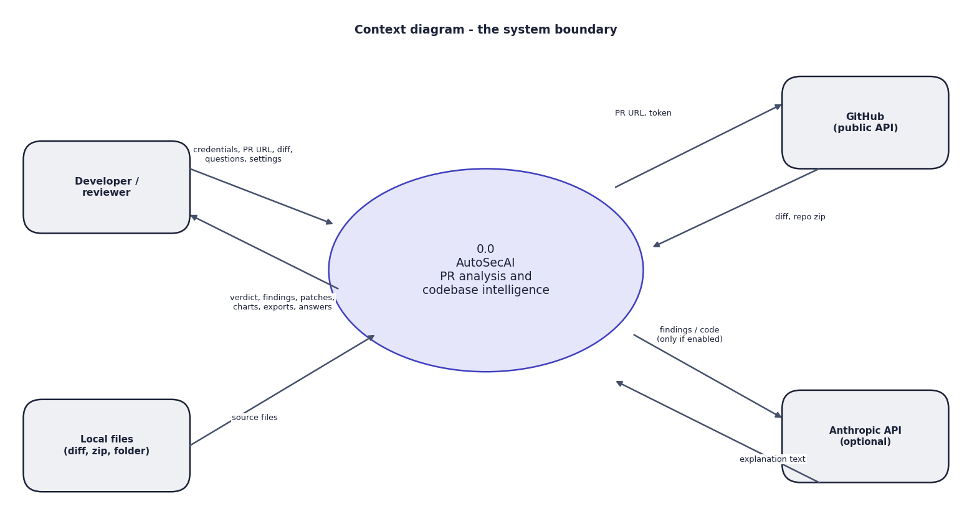
Fig. 1: Data-flow diagram, level 0 (context)
AutoSecAI is one process with four external entities. The developer sends credentials, pull-request URLs, diffs, files, questions and settings and receives a verdict, findings, patches, charts, exports and answers. Local files supply source code. GitHub returns a diff or a repository archive for a URL. The Anthropic API receives text only when the optional language-model mode is on.
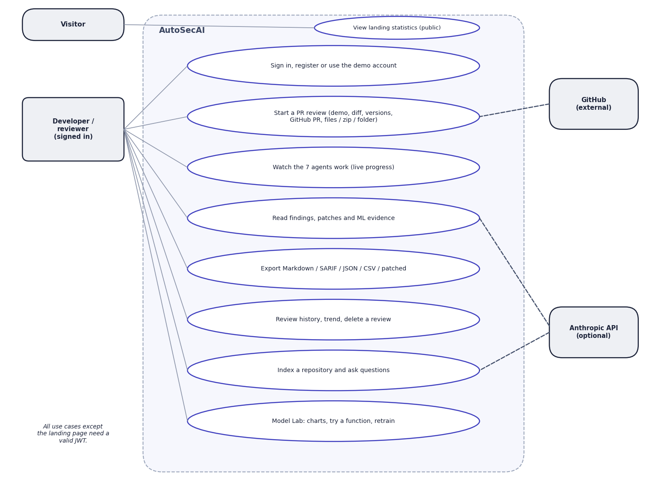
Fig. 2: Use-case diagram
The signed-in developer has eight use cases: sign in, register or use the demo account; start a review through any of five inputs; watch the agents work; read findings, patches and ML evidence; export Markdown, SARIF, JSON, CSV or patched files; use the history; index a repository and ask questions; and use the Model Lab. A visitor can only view the landing statistics. GitHub attaches to starting a review and the optional Anthropic API to reading findings and repository questions.

3 Limitations and Assumptions
The limitations below qualify every number in this report; Chapter 8 returns to them with the evidence.
Table 1: Limitations of the system and of the evidence
Limitation | Consequence for the reader
The classifier is trained on a generated Python corpus of 6,000 functions (501 vulnerable, 8.35 %). The base paper's C/C++ data are not bundled. | Scores show that the pipeline works; they are a prioritisation signal, not proof of exploitability, and are not comparable with the paper's F1 of 0.961.
The corpus generator and the rules were written by the same team around the same eight weakness patterns, and 1 % of labels are deliberately noisy. | The rule-engine figures are optimistic for real code; a few positives contain no vulnerable code and no detector can find them.
The headline F1 of 0.851 is the best of five corpus seeds (mean 0.842 +/- 0.006 for XGBoost). | Quote the mean when comparing; the number of metrics kept (k = 13) was not re-selected for each seed.
The ablation changes the number of metrics and the balancing at the same time. | The separate effect of SMOTE-Tomek was not isolated; recall was identical with and without it.
No labelled set of real, manually reviewed pull requests exists, so objective 6 (precision against manual review) was not measured. No comparison with Bandit, Semgrep or CodeQL was run. | The real-world precision of the review is unknown.
The 'multi-agent' design is seven deterministic software agents plus an optional LLM text layer. The LLM layer was not measured (no API key was available). | All reported results describe the offline pipeline.
Deep analysis is Python-only; JavaScript, PHP and Java use regex rules. Whole-file fixes exist only when a full file is supplied, not for a bare diff hunk. | Findings in other languages are less precise; some diff-only findings have no patch.
The review history is shared by all accounts (the reviews table has no user column), and jobs live in memory. | Not suitable for several users on one deployment; running jobs are lost on restart.
Fetching a real GitHub pull request was tested only with an invalid URL (readable error); the Streamlit interface could not be run on the build machine. | The GitHub path rests on the code and its error handling, not on a live fetch.

Assumptions are listed in the section on scope. The most important is that source-code metrics carry a vulnerability signal in Python as in C and C++ [1]; this project does not test that on real Python vulnerabilities.

4 Advantages and Constraints
Table 2: Advantages and constraints of the project
Advantages | Constraints
Runs on one laptop, offline, with no GPU and no licence fee | ML model trained on a generated Python corpus; not validated on real Python vulnerabilities
Several independent detectors (rules, taint, learned model) that can be cross-checked | Deep analysis for Python only; other languages use regex rules
Every finding explained, mapped to a CWE and, where possible, patched and re-scanned | Whole-file patches need the full file; a bare diff hunk gets fewer patches
Standard exports (Markdown, SARIF 2.1.0, JSON, CSV) | No labelled real-PR benchmark; precision on manually reviewed PRs not measured
Source code stays on the user's machine; the LLM layer is optional and off by default | The optional LLM layer was not measured; GitHub fetch was tested only with an invalid URL
Repeatable tests and measurements | Single-machine design: in-memory jobs, SQLite, a review history shared across accounts

5 Limits of the Testing Done
The tests establish that the system works as designed on the data used. They do not establish how well it performs on real software, and the following limits should be kept in mind when reading the results.
- Synthetic evaluation data. The model scores and the comparison of the rule engine with the model come from a generated corpus. They are not evidence of performance on real vulnerable code.
- No real pull-request benchmark. Objective six of the project asked for precision against manually reviewed pull requests. No labelled set of real pull requests was available, so this was not measured; the only demonstration is the built-in vulnerable pull request, which was written for the purpose.
- No comparison with other tools. The analyser was not compared with existing scanners such as Bandit, Semgrep or CodeQL.
- GitHub was not exercised with a real pull request. Only the error path of an invalid link was tested, because the tests avoid the network.
- The language-model layer was never run. No key was available, so the optional explanation and answer rewriting is untested and unmeasured.
- Small retrieval check. Twelve questions on a ten-file repository, written by the developers.
- No load, concurrency or soak test. Timings are for one client on one machine; memory use was not measured.
- No usability study and no security audit beyond the checks listed above.
- One machine, one browser. Everything ran on Windows 11 with Chrome; other browsers and systems were not tested, and the Streamlit interface was not run.

6 Limits of the Results
- Generated data. The model was trained and tested on 6,000 generated Python functions; its F1 of 0.851 does not show how it performs on real repositories, and the rule evaluation is optimistic because the rules and the generator were written by the same team.
- Best of five. The headline XGBoost F1 is the best of five corpora (mean 0.842 +/- 0.006); the number of metrics was not re-selected for each corpus and the ablation is confounded.
- No real labelled pull requests. Precision and recall of the whole system on real pull requests were not measured, and no comparison with Bandit, Semgrep or CodeQL was run.
- Untested paths. The optional language-model mode (no API key) and the fetch of a real GitHub pull request (only the error path) were not tested; the retrieval check covers one small repository.
- One machine, no user study. All timings come from one desktop computer; no load test was run and no developer rated the findings or the answers.

